**PERFORMANCE MANAGEMENT POLICY**

**TABLE OF CONTENTS**

1. **OBJECTIVE**
2. **SCOPE**
3. **PURPOSE**
4. **APPRAISAL CYCLE TIMELINE**
5. **IMPORTANCE OF SUPREMOLOGY ANNUAL APPRAISAL**
6. **PERFORMANCE MANAGEMENT PROCESS**
7. **PERFORMANCE APPRAISAL STEPS**
8. **RATING SCALE AND RATING DESCRIPTION**
9. **CAREER PATHS**
10. **IDENTIFYING AND MANAGING POOR PERFORMERS**
11. **WHAT IS A PERFORMANCE MANAGEMENT PLAN (PIP)**
12. **PROCESS TO HANDLE POOR PERFORMERS**
13. **DISCLAIMER**

|  |  |  |  |  |
| --- | --- | --- | --- | --- |
| **DOCUMENT REVISION HISTORY** | | | | |
| **Release Version** | **Modified Date** | **Modified By** | **Changes** | **Approval Authority** |
| 2.0 | 01/11/2019 | HR | Performance management guidelines policy | Head, HR |

1. **OBJECTIVE**

To develop a framework to carry out a fair & effective performance management program that is aligned to the business goals.

1. **SCOPE:**

Applicable to full time employees of Supremology India Pvt Ltd.

1. **PURPOSE**

The purpose of performance management process is to create a valuable opportunity for managers and employees to have time out for one on one discussion to focus on goal setting competencies assessment and development plan for the new year. This is also an opportunity for performance assessment, competency review, and development planning for the past years. It also is the time to review career goals for the future.

1. **APPRAISAL CYCLE TIMELINE**

Supremology follows annual appraisal cycle between January to December. Any employee who has joined on or before 30th September are covered under AAA.

1. **IMPORTANCE OF SUPREMOLOGY ANNUAL APPRAISAL (AAA)**

The Supremology Annual Appraisal offers, in the rush and bustle of working life, a valuable opportunity for Managers and Employees to have “time-out” for one-one-one discussion to focus on

**PERFORMANCE REVIEW**

**COMPETENCY REVIEW**

* Identifying and understand the competencies required for the job
* Assessing current competency levels
* Analyzing the gap between current competencies and the ones to be strengthened
* Assessing Employee Performance compared to goals for their role in the past period
* Providing Employees helpful and meaningful using concrete examples
* Listening to Employees point of view and comments

**GOAL SETTING**

**DEVELOPMENT PLANNING**

* Encouraging employees to grow and develop competencies by mixing different learning activities, Formal trainings, On-the-Job learning, Coaching & mentoring, Unstructured Learning, Special Projects and Secondments
* Discussing career

evolution and opportunities

* Defining Specific, Measurable, Attainable, Results-oriented, Timely goals
* Validating goals with Employees to ensure alignment and commitment
* Enabling Employees to align their efforts behind Supremology strategic direction

1. **PERFORMANCE MANAGEMENT PROCESS**

Supremology Performance Management Program will include 5 point- Rating scale review process. Manager assess the employee’s overall performance in the Supremology Appraisal form followed by rating in the XYZ tool.

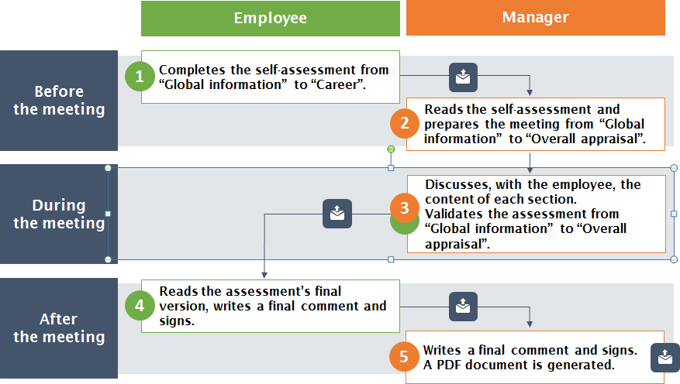

1. **PERFORMANCE APPRASIAL STEPS**

Below are the steps to be followed in the entire Performance Management Program.

|  |  |  |
| --- | --- | --- |
| **Step/Activity** | **Activity Detail** | **Responsibility** |
| **Self-assessment for the current year & Goal setting for the next year** | Employee to complete the self-assessment in AAA form from “Global Information" to "Career". | Employees |
| **Manager Review** | Manager reads the self- assessment in AAA form from "Global information" to "Overall appraisal" | Manager |
| **Appraisal Discussion b/w Employee & the Manager** | After the employee self- assessment, manager discusses with the employee, the content of each section. Validates the assessment from “Global information” to “Overall appraisal | Manager |
| **Employee Acknowledgement** | Employee reads the assessment final version, writes a final comment & sign off. | Employees |
| **Final Rating** | Manager enters the final comment/rating, followed by sign off. | Manager |
| **Calibration** | HR handles the calibration at the business level | HR/ Business head |
| **Merit Increase/ Promotion** | HR Operations processes the merit increase/ promotions/issues increment letters based on the merit  guideline | HR/HR Operations |

The entire Appraisal activity needs to be updated in the Talent Management System (TMS).

1. **RATING SCALE AND RATING DESCRIPTION**

Rating scale is used for performance evaluation is 1 to 5. Rating definition & rating descriptions are given below:

|  |  |  |  |
| --- | --- | --- | --- |
| **Rating** | **Rating Scale** | **Achievement Criteria** | **Rating Definition** |
| **5** | **Exceeds expectations** | Achievement ≥105% | Consistently goes beyond the expected results and the position skills’ requirements. Excels at what he/she does. |
| **4** | **Fully meet expectations** | Achievement ≥95% to <105% | Performs consistently well with regards to the expected results. Fulfils the position skills’ requirements. Can be counted on to get the job done. |
| **3** | **Mostly meet expectations** | Achievement ≥75% to <95% | Performs at expected level most of the time and below expected level at other times. Fulfil most of the position’s skills requirements. Needs an action plan to further develop targeted areas |
| **2** | **Partially meet expectations** | Achievement ≥50% to <75% | Performs at expected level some of the time and below expected level at other times. Fulfil part of the position’s skills requirements. Needs an action plan to improve targeted areas |
| **1** | **Does not meet expectations** | Achievement <50% | Is below standard with regards to the expected results. Does not fulfil the position’s skills requirements. Needs an immediate action plan and/or move to consider. |

1. **CAREER PATHS**

Across global Supremology has implemented career path with the below objectives. In order to meet the Group’s development objectives.

* Strengthen our capability to manage customer projects and to intervene on more complex and strategic topics that require more specialized expertise and focus.
* Better visibility and better development opportunities
* In response to what is expressed by our customers and partners to have more multidisciplinary and international teams.
* Our HR policy is changing career paths are a concrete illustration of this change.
* Among the four top priorities of C.A.R.E., Career paths are designed to recognize and develop the expertise of our talents.

1. **IDENTIFYING AND MANAGING POOR PERFORMERS**

The objective is to provide a guideline and action plan for employees who are poor performers as per appraisal ratings. Timeline for Performance Improvement Plan (PIP) is Minimum 30 and Maximum 90 calendar days. If the performance does not improve by the end of review period, PIP can be extended by a month at manager/HRBP discretion.

1. **What is a Performance Improvement Plan (PIP)?**

* A Performance Improvement Plan, also known as a PIP, is a formal document that is used by businesses and companies to evaluate an employee's performance and set goals on how this performance can be improved. The form may be used for anyone from a manager to an entry level associate.
* This form will typically include several steps that will be followed for the employee to improve their job performance. A time limit may be included. The employee must do their best to meet these steps for performance improvement by that time or consequences may be given.
* A PIP may be given to an employee during performance review season after an unsatisfactory performance review.  The PIP process will give an employee a chance to learn more and change before disciplinary action is taken.
* It can also be appropriate for someone who is new to a position and is having trouble figuring out what to do.
* This form lists goals in a formal way, so all parties involved will understand the expectations of the employee.

1. **PROCESS TO HANDLE POOR PERFORMERS**

* Manager needs to identify the poor performer & develop a PIP plan. Employees with poor performance are put under PIP for duration of 1 to 3 months.
* Goals to be specific, measurable and realistic and to be contained within the target review period.
* Manager needs to discuss the plan with HRBP.
* Meeting to be organized by the manager with the employee in presence of the HRBP to explain the PIP plan to employee
* Manager to issue the PIP and take a sign-off on the PIP issuance form followed by
* Monthly Interim reviews
* If required, PIP can be extended for additional (maximum) 30 days from end of review period date. Manager and HRBP to issue Extension Letter to the employee.
* In case of the improvement of the performance, HRBP closes the PIP. If the performance does not improve, termination process will be initiated.

# Annexures to the PIP: Refer to the XYZ Portal

* PIP Form for Employee
* PIP Assessment document

1. **DISCLAIMER**

This policy and its contents are confidential and intended solely for the use by employees of Supremology Software Services Pvt. Ltd. Transmitting, Disclosing, Copying, distributing these contents to other than the intended recipient / users are strictly prohibited. It is the sole discretion of the Management to change, amend the entire policy and/or its clause/s from time to time and/or withdraw the same, without any notice. This policy supersedes all earlier versions if any.